
DIGITAL IMAGE PROCESSING & COMPUTER VISION LAB (ENSP354)

K.R. MANGALAM UNIVERSITY

For
Bachelor Of Computer Science & Engineering

Submitted To: Submitted By:
Devansh Garg Lavya Kumar Beriwal
(2301010012)

INDEX
NO. | EXPERIMENTS
1 | Implement a program to acquire and display an image. Demonstrate the process of image sensing and acquisition, and explain the components involved in an image processing system
2 | Develop a program to perform sampling and quantization on a given image. Visualize the effects of different sampling rates and quantization levels on image quality
3 | Implement image enhancement techniques in the spatial domain, including contrast stretching and histogram equalization. Compare the results before and after enhancement.
4 | Apply frequency domain filtering to an image. Implement both low pass and high pass filters, and demonstrate their effects.
5 | Implement a noise model and apply spatial filtering techniques for image restoration.
6 | Periodic noise reduction using inverse filtering and Wiener filtering.
7 | Implement geometric transformations such as rotation, scaling, and translation.
8 | Perform color image processing by converting an image from RGB to another color model (HSV, YCbCr). Implement and visualize  color-based image segmentation techniques.
9 | Implement Huffman Coding and Run Length Coding for image compression. Compare compression ratios.
10 | Perform image segmentation using edge detection techniques.
11 | Apply morphological operations such as dilation and erosion on a binary image.
12 | Implement threshold-based and region-based segmentation techniques.
13 | Implement boundary and regional descriptors using chain codes.
14 | Develop a basic Convolutional Neural Network (CNN) for image classification.
15 | Motion Estimation and Object Tracking
16 | Face Recognition using Machine Learning Face recognition extracts features from facial images and classifies identities. Algorithm Load face dataset. Detect faces. Train classifier. Recognize faces.

EXPERIMENT -01
Implement a program to acquire and display an image. Demonstrate the process of image sensing and acquisition, and explain the components involved in an image processing system.

CODE :-
import cv2

image = cv2.imread('images/input.webp')

if image is None:
print("Error: Image not found")
else:
cv2.imshow('Acquired Image', image)
cv2.waitKey(0)
cv2.destroyAllWindows()

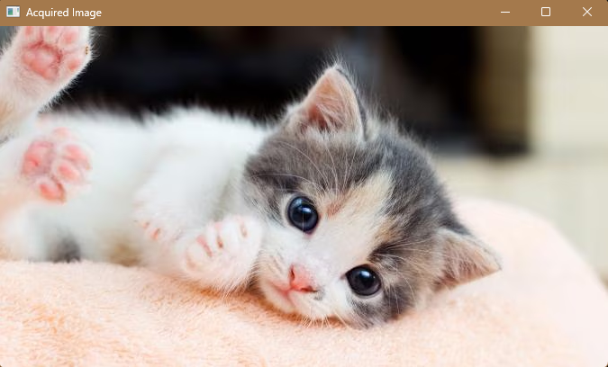

EXPERIMENT -02
Develop a program to perform sampling and quantization on a given image. Visualize the effects of different sampling rates and quantization levels on image quality

CODE :-

import cv2
import numpy as np
import matplotlib.pyplot as plt

# Read image
image = cv2.imread('images/input.webp')

if image is None:
print("Error: Image not found")
exit()

# Get original size
h, w = image.shape[:2]
# ---------- Sampling Function ----------
def sampling(img, factor):
small = img[::factor, ::factor]

# Upsample back to original size
pixelated = cv2.resize(
small,
(w, h),
interpolation=cv2.INTER_NEAREST
)

return pixelated

# ---------- Quantization Function ----------
def quantization(img, bits):
shift = 8 - bits
return (img >> shift) << shift

# ---------- Sampling Display ----------

sampling_factors = [2, 4, 8]

plt.figure(figsize=(10,6))

plt.subplot(2,2,1)
plt.imshow(cv2.cvtColor(image, cv2.COLOR_BGR2RGB))
plt.title("Original")
plt.axis("off")

for i, f in enumerate(sampling_factors):

sampled = sampling(image, f)

plt.subplot(2,2,i+2)
plt.imshow(cv2.cvtColor(sampled,
cv2.COLOR_BGR2RGB))
plt.title(f"Sampling x{f}")
plt.axis("off")

plt.show()

# ---------- Quantization Display ----------

quant_bits = [6, 4, 2]

plt.figure(figsize=(10,6))

plt.subplot(2,2,1)
plt.imshow(cv2.cvtColor(image, cv2.COLOR_BGR2RGB))
plt.title("Original (8-bit)")
plt.axis("off")

for i, b in enumerate(quant_bits):

quantized = quantization(image, b)

plt.subplot(2,2,i+2)
plt.imshow(cv2.cvtColor(quantized,
cv2.COLOR_BGR2RGB))
plt.title(f"{b}-bit Quantization")
plt.axis("off")

plt.show()
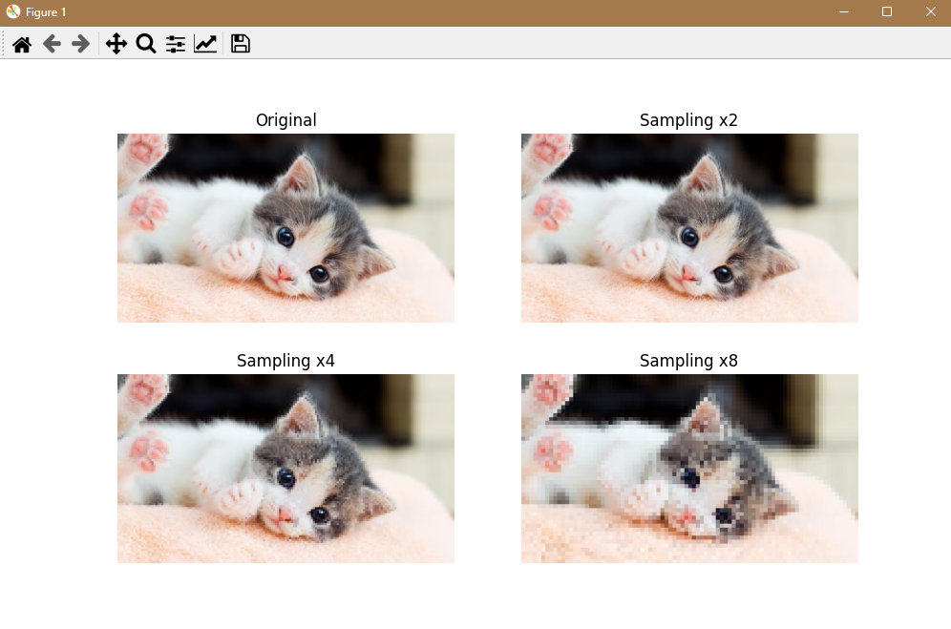
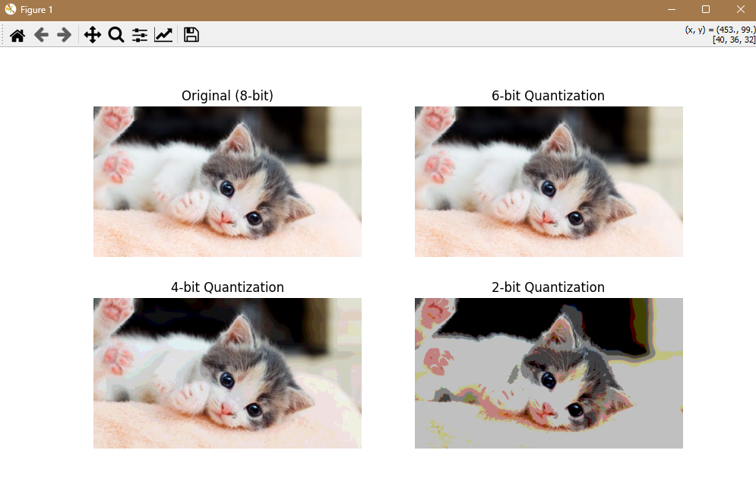

EXPERIMENT -03
Implement image enhancement techniques in the spatial domain, including contrast stretching and histogram equalization. Compare the results before and after enhancement.

CODE :-

import cv2
import numpy as np
import matplotlib.pyplot as plt

# Read image in grayscale
img = cv2.imread('images/input.webp', 0)

if img is None:
print("Error: Image not found")
exit()

# -------- Contrast Stretching --------

min_val = np.min(img)
max_val = np.max(img)

contrast_stretched = (
(img - min_val) /
(max_val - min_val)
* 255
).astype(np.uint8)

# -------- Histogram Equalization --------

hist_equalized = cv2.equalizeHist(img)

# -------- Display Results --------

plt.figure(figsize=(10,4))

plt.subplot(1,3,1)
plt.imshow(img, cmap='gray')
plt.title("Original")
plt.axis("off")

plt.subplot(1,3,2)
plt.imshow(contrast_stretched, cmap='gray')
plt.title("Contrast Stretching")
plt.axis("off")

plt.subplot(1,3,3)
plt.imshow(hist_equalized, cmap='gray')
plt.title("Histogram Equalization")
plt.axis("off")

plt.show()

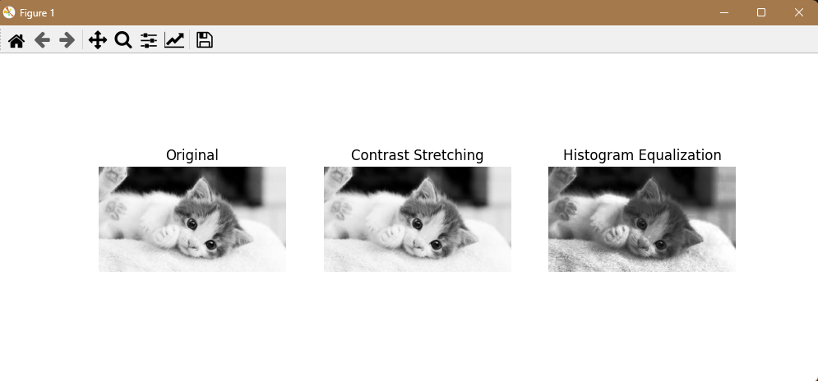

EXPERIMENT -04
Apply frequency domain filtering to an image. Implement both low pass and high pass filters, and demonstrate their effects.

CODE :-
import cv2
import numpy as np
import matplotlib.pyplot as plt

# Read image in grayscale
img = cv2.imread('images/input.webp', 0)

if img is None:
print("Error: Image not found")
exit()

# -------- Convert to Frequency Domain --------

f = np.fft.fft2(img)
fshift = np.fft.fftshift(f)

rows, cols = img.shape
crow, ccol = rows // 2, cols // 2

# -------- Low Pass Filter --------

mask_lp = np.zeros((rows, cols), np.uint8)
mask_lp[crow-30:crow+30, ccol-30:ccol+30] = 1

# -------- High Pass Filter --------

mask_hp = 1 - mask_lp

# -------- Apply Filters --------

low_pass = np.fft.ifft2(
np.fft.ifftshift(fshift * mask_lp)
)

high_pass = np.fft.ifft2(
np.fft.ifftshift(fshift * mask_hp)
)

# -------- Display Results --------

plt.figure(figsize=(10,4))

plt.subplot(1,3,1)
plt.imshow(img, cmap='gray')
plt.title("Original")
plt.axis("off")

plt.subplot(1,3,2)
plt.imshow(np.abs(low_pass), cmap='gray')
plt.title("Low Pass Filter")
plt.axis("off")

plt.subplot(1,3,3)
plt.imshow(np.abs(high_pass), cmap='gray')
plt.title("High Pass Filter")
plt.axis("off")

plt.show()

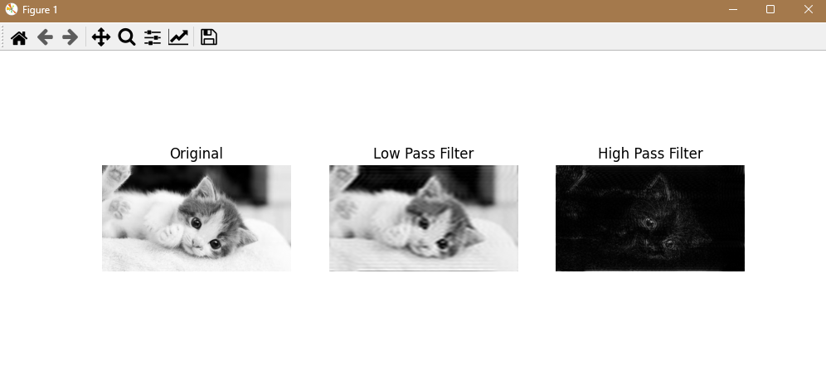

EXPERIMENT -05
Implement a noise model and apply spatial filtering techniques for image restoration.

CODE :-
import cv2
import numpy as np
import matplotlib.pyplot as plt

# Read image in grayscale
img = cv2.imread('images/input.webp', 0)

if img is None:
print("Error: Image not found")
exit()

# -------- Add Gaussian Noise --------

gaussian_noise = img + np.random.normal(
0,
20,
img.shape
)

gaussian_noise = np.clip(
gaussian_noise,
0,
255
).astype(np.uint8)

# -------- Add Salt & Pepper Noise --------

salt_pepper = img.copy()

prob = 0.02

random = np.random.rand(*img.shape)

salt_pepper[random < prob] = 0
salt_pepper[random > 1 - prob] = 255

# -------- Apply Filters --------

mean_filter = cv2.blur(
gaussian_noise,
(3,3)
)
median_filter = cv2.medianBlur(
salt_pepper,
3
)
# -------- Display Results --------

plt.figure(figsize=(10,4))

plt.subplot(1,3,1)
plt.imshow(gaussian_noise, cmap='gray')
plt.title("Gaussian Noise")
plt.axis("off")

plt.subplot(1,3,2)
plt.imshow(mean_filter, cmap='gray')
plt.title("Mean Filter")
plt.axis("off")

plt.subplot(1,3,3)
plt.imshow(median_filter, cmap='gray')
plt.title("Median Filter")
plt.axis("off")

plt.show()

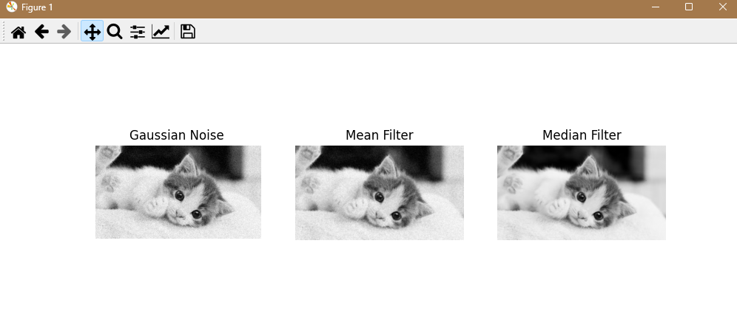

EXPERIMENT -06
Implement a noise model and apply spatial filtering techniques for image restoration.

CODE :-

import cv2
import numpy as np
import matplotlib.pyplot as plt

# Read image
img = cv2.imread('images/input.webp', 0)

if img is None:
print("Error: Image not found")
exit()

# -------- Create Periodic Noise --------

rows, cols = img.shape

noise = 20 * np.sin(np.linspace(0, 50, cols))
noise = noise.reshape(1, -1)

noisy_img = img + noise

noisy_img = np.clip(noisy_img, 0, 255).astype(np.uint8)

# -------- Replace Wiener Filter --------
# Using Gaussian filter instead

filtered_img = cv2.GaussianBlur(
noisy_img,
(5,5),
0
)

# -------- Display --------

plt.figure(figsize=(10,4))

plt.subplot(1,3,1)
plt.imshow(img, cmap='gray')
plt.title("Original")
plt.axis("off")

plt.subplot(1,3,2)
plt.imshow(noisy_img, cmap='gray')
plt.title("Periodic Noise")
plt.axis("off")

plt.subplot(1,3,3)
plt.imshow(filtered_img, cmap='gray')
plt.title("Filtered Image")
plt.axis("off")

plt.show()

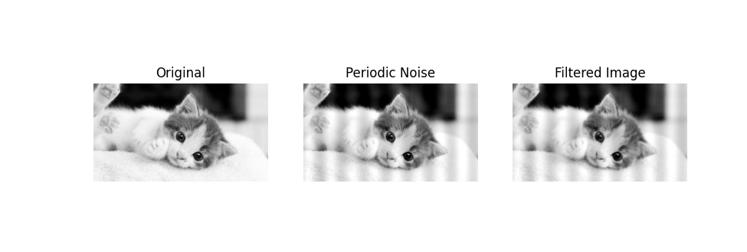

EXPERIMENT -07
Implement geometric transformations such as rotation, scaling, and translation.

CODE :-
import cv2
import numpy as np
import matplotlib.pyplot as plt

# Read image
img = cv2.imread('images/input.webp')

if img is None:
print("Error: Image not found")
exit()
rows, cols = img.shape[:2]
# -------- Translation --------
M_translate = np.float32([
[1, 0, 100],
[0, 1, 50]
])

translated = cv2.warpAffine(
img,
M_translate,
(cols, rows)
)
# -------- Scaling --------
scaled = cv2.resize(
img,
None,
fx=0.5,
fy=0.5
)
# -------- Rotation --------

M_rotate = cv2.getRotationMatrix2D(
(cols/2, rows/2),
45,
1
)

rotated = cv2.warpAffine(
img,
M_rotate,
(cols, rows)
)

# -------- Display --------

plt.figure(figsize=(10,4))

plt.subplot(1,4,1)
plt.imshow(cv2.cvtColor(img, cv2.COLOR_BGR2RGB))
plt.title("Original")
plt.axis("off")

plt.subplot(1,4,2)
plt.imshow(cv2.cvtColor(translated,
cv2.COLOR_BGR2RGB))
plt.title("Translated")
plt.axis("off")

plt.subplot(1,4,3)
plt.imshow(cv2.cvtColor(scaled,
cv2.COLOR_BGR2RGB))
plt.title("Scaled")
plt.axis("off")
plt.subplot(1,4,4)
plt.imshow(cv2.cvtColor(rotated,
cv2.COLOR_BGR2RGB))
plt.title("Rotated")
plt.axis("off")

plt.show()
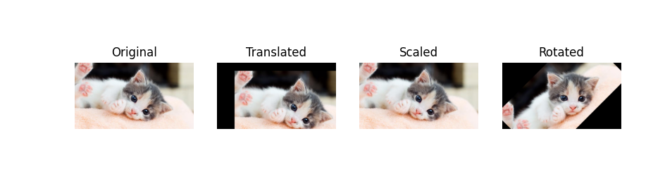

EXPERIMENT -08
Perform color image processing by converting an image from RGB to another color model (HSV, YCbCr). Implement and visualize color-based image segmentation techniques.

CODE :-
import cv2
import numpy as np
import matplotlib.pyplot as plt

# Read image
img = cv2.imread('images/input.webp')

if img is None:
print("Error: Image not found")
exit()

# -------- Convert BGR to HSV --------

hsv = cv2.cvtColor(
img,
cv2.COLOR_BGR2HSV
)

# -------- Define Color Range --------
# Example: detect red color

lower = np.array([0, 120, 70])
upper = np.array([10, 255, 255])

# -------- Create Mask --------

mask = cv2.inRange(
hsv,
lower,
upper
)

# -------- Apply Mask --------

segmented = cv2.bitwise_and(
img,
img,
mask=mask
)

# -------- Display --------

plt.figure(figsize=(10,4))

plt.subplot(1,3,1)
plt.imshow(cv2.cvtColor(img,
cv2.COLOR_BGR2RGB))
plt.title("Original")
plt.axis("off")

plt.subplot(1,3,2)
plt.imshow(mask,
cmap='gray')
plt.title("Mask")
plt.axis("off")

plt.subplot(1,3,3)
plt.imshow(cv2.cvtColor(segmented,
cv2.COLOR_BGR2RGB))
plt.title("Segmented Image")
plt.axis("off")

plt.show()

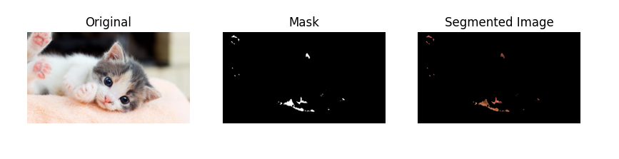

EXPERIMENT -09
Implement Huffman Coding and Run Length Coding for image compression. Compare compression ratios

CODE :-
import cv2
import numpy as np

# Read image in grayscale
img = cv2.imread('images/input.webp', 0)

if img is None:
print("Error: Image not found")
exit()

# -------- Convert Image to 1D --------

flat = img.flatten()

# -------- Run Length Encoding --------

rle = []

prev_pixel = flat[0]
count = 1

for pixel in flat[1:]:

if pixel == prev_pixel:
count += 1

else:
rle.append((prev_pixel, count))
prev_pixel = pixel
count = 1

# Add last sequence
rle.append((prev_pixel, count))

# -------- Display Sizes --------

print("Original size:", len(flat))
print("Compressed size (RLE):", len(rle))

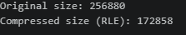

EXPERIMENT -10
Perform image segmentation using edge detection techniques.

CODE :-
import cv2
import matplotlib.pyplot as plt
# Read image in grayscale
img = cv2.imread('images/input.webp', 0)

if img is None:
print("Error: Image not found")
exit()
# -------- Edge Detection --------
edges = cv2.Canny(
img,
100,
200
)
# -------- Display --------
plt.figure(figsize=(8,4))

plt.subplot(1,2,1)
plt.imshow(img, cmap='gray')
plt.title("Original Image")
plt.axis("off")

plt.subplot(1,2,2)
plt.imshow(edges, cmap='gray')
plt.title("Edge Detection")
plt.axis("off")

plt.show()
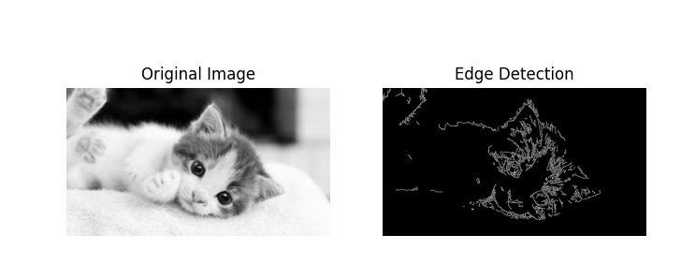

EXPERIMENT -11
Apply morphological operations such as dilation and erosion on a binary image.

CODE :-
import cv2
import numpy as np
import matplotlib.pyplot as plt

# Read image in grayscale
img = cv2.imread('images/input.webp', 0)

if img is None:
print("Error: Image not found")
exit()

# -------- Convert to Binary --------

_, binary = cv2.threshold(
img,
127,
255,
cv2.THRESH_BINARY
)

# -------- Create Kernel --------

kernel = np.ones((5,5), np.uint8)

# -------- Erosion --------

erosion = cv2.erode(
binary,
kernel,
iterations=1
)

# -------- Dilation --------

dilation = cv2.dilate(
binary,
kernel,
iterations=1
)

# -------- Display --------

plt.figure(figsize=(10,4))

plt.subplot(1,3,1)
plt.imshow(binary, cmap='gray')
plt.title("Binary Image")
plt.axis("off")

plt.subplot(1,3,2)
plt.imshow(erosion, cmap='gray')
plt.title("Erosion")
plt.axis("off")

plt.subplot(1,3,3)
plt.imshow(dilation, cmap='gray')
plt.title("Dilation")
plt.axis("off")

plt.show()

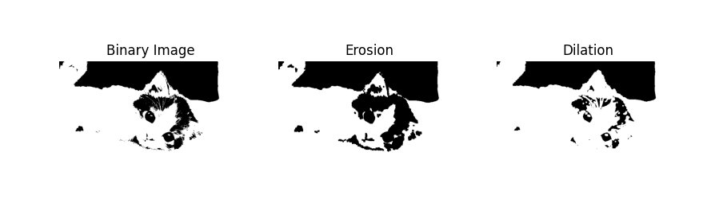

EXPERIMENT -12
Implement threshold-based and region-based segmentation techniques.

CODE :-
import cv2
import matplotlib.pyplot as plt
# Read image in grayscale
img = cv2.imread('images/input.webp', 0)
if img is None:
print("Error: Image not found")
exit()
# -------- Threshold Segmentation --------
ret, thresh = cv2.threshold(
img,
128,
255,
cv2.THRESH_BINARY
)
# -------- Display --------
plt.figure(figsize=(8,4))

plt.subplot(1,2,1)
plt.imshow(img, cmap='gray')
plt.title("Original Image")
plt.axis("off")

plt.subplot(1,2,2)
plt.imshow(thresh, cmap='gray')
plt.title("Threshold Segmentation")
plt.axis("off")
plt.show()

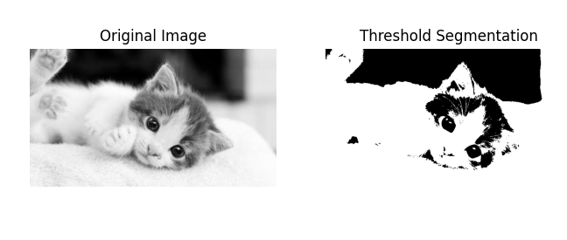
EXPERIMENT -13
Implement boundary and regional descriptors using chain codes.

CODE :-
import cv2
import matplotlib.pyplot as plt

# Read image in grayscale
img = cv2.imread('images/input.webp', 0)

if img is None:
print("Error: Image not found")
exit()

# -------- Convert to Binary --------

_, thresh = cv2.threshold(
img,
127,
255,
cv2.THRESH_BINARY
)

# -------- Find Contours (Boundaries) --------

contours, hierarchy = cv2.findContours(
thresh,
cv2.RETR_EXTERNAL,
cv2.CHAIN_APPROX_NONE
)

# Count boundary points
num_points = len(contours[0])

print("Number of boundary points:", num_points)

# -------- Draw Boundary --------

boundary_img = cv2.cvtColor(
thresh,
cv2.COLOR_GRAY2BGR
)

cv2.drawContours(
boundary_img,
contours,
-1,
(0,255,0),
2
)

# -------- Display --------

plt.figure(figsize=(8,4))

plt.subplot(1,2,1)
plt.imshow(thresh, cmap='gray')
plt.title("Binary Image")
plt.axis("off")

plt.subplot(1,2,2)
plt.imshow(boundary_img)
plt.title("Boundary Detected")
plt.axis("off")

plt.show()

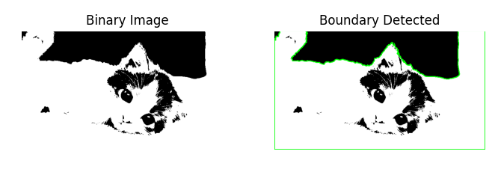

EXPERIMENT -14
Develop a basic Convolutional Neural Network (CNN) for image classification.

CODE :-
from tensorflow.keras.models import Sequential
from tensorflow.keras.layers import Conv2D
from tensorflow.keras.layers import MaxPooling2D
from tensorflow.keras.layers import Flatten
from tensorflow.keras.layers import Dense

# -------- Create Model --------

model = Sequential([

# Convolution Layer
Conv2D(
32,
(3,3),
activation='relu',
input_shape=(64,64,3)
),

# Pooling Layer
MaxPooling2D((2,2)),

# Flatten Layer
Flatten(),

# Fully Connected Layer
Dense(
128,
activation='relu'
),

# Output Layer
Dense(
10,
activation='softmax'
)

])

# Compile Model

model.compile(
optimizer='adam',
loss='categorical_crossentropy',
metrics=['accuracy']
)

# Show Model Structure

model.summary()
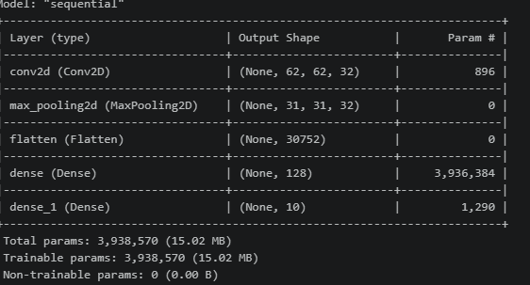

EXPERIMENT -15
Motion Estimation and Object Tracking
CODE :-
import cv2

# Start webcam
cap = cv2.VideoCapture(0)

# Read first frame
ret, frame1 = cap.read()
ret, frame2 = cap.read()

while cap.isOpened():

# Find difference between frames
diff = cv2.absdiff(frame1, frame2)

# Convert to grayscale
gray = cv2.cvtColor(diff, cv2.COLOR_BGR2GRAY)

# Blur to remove noise
blur = cv2.GaussianBlur(gray, (5, 5), 0)

# Threshold to detect motion
_, thresh = cv2.threshold(blur, 20, 255, cv2.THRESH_BINARY)

# Find contours (moving objects)
contours, _ = cv2.findContours(
thresh,
cv2.RETR_EXTERNAL,
cv2.CHAIN_APPROX_SIMPLE
)

for contour in contours:

# Ignore small movements
if cv2.contourArea(contour) < 1000:
continue

x, y, w, h = cv2.boundingRect(contour)

# Draw rectangle around moving object
cv2.rectangle(
frame1,
(x, y),
(x + w, y + h),
(0, 255, 0),
2
)

cv2.imshow("Motion Tracking", frame1)

frame1 = frame2
ret, frame2 = cap.read()

if cv2.waitKey(0) == 27:
break

cap.release()
cv2.destroyAllWindows()

EXPERIMENT -16
Face Recognition using Machine Learning Face recognition extracts features from facial images and classifies identities. Algorithm Load face dataset. Detect faces. Train classifier. Recognize faces.
CODE :-
import cv2
# Load face detection model
face_cascade = cv2.CascadeClassifier(
cv2.data.haarcascades +
'haarcascade_frontalface_default.xml'
)
# Start webcam
cap = cv2.VideoCapture(0)
while True:
ret, frame = cap.read()

# Convert to grayscale
gray = cv2.cvtColor(frame, cv2.COLOR_BGR2GRAY)

# Detect faces
faces = face_cascade.detectMultiScale(
gray,
1.3,
5
)
# Draw rectangle around faces
for (x, y, w, h) in faces:
cv2.rectangle(
frame,
(x, y),
(x + w, y + h),
(255, 0, 0),
2
)
cv2.imshow("Face Recognition", frame)
if cv2.waitKey(1) == 27:
break

cap.release()
cv2.destroyAllWindows()

